Project Development PhaseSprint I

SPRINT TARGETS:
Date | 15 November 2022
Team ID | PNT2022TMID44492
Project Name | Signs with Smart Connectivity for better road safety
Sprint | Functional Requirement (Epic) | User Story Number | User Story / Task | Story Points | Priority | Team Members
Sprint-1 | Dynamic Speed  Limit | USN-1 | As a traveller , It is Essential form to  know the speed limit | 10 | High | Pavithra Rohini Naresh Mallisri
Sprint-1 | Priority Vehicle | USN-2 | Simulating the circuits and experimenting | 2 | High | Pavithra Rohini Naresh Mallisri
Sprint-1 | Weather Speed Limit | USN-3 | As a user ,I should be aware of weather influence on speed limit for safer ride |  | Medium | Pavithra Rohini Naresh Mallisri

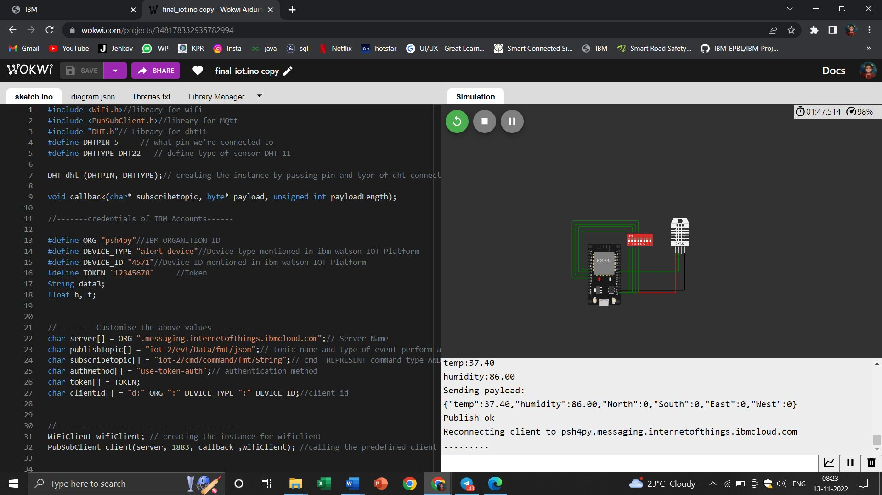
Wokwi Simulation: https://wokwi.com/projects/348178332935782994

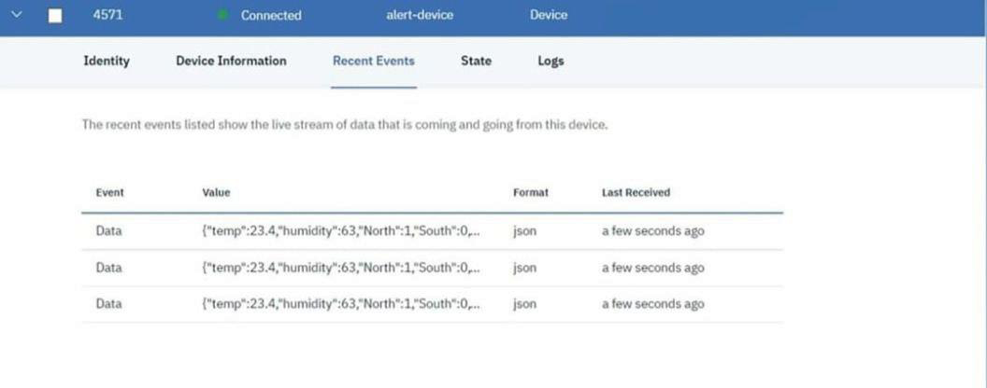
IoT Device – IoT Platform
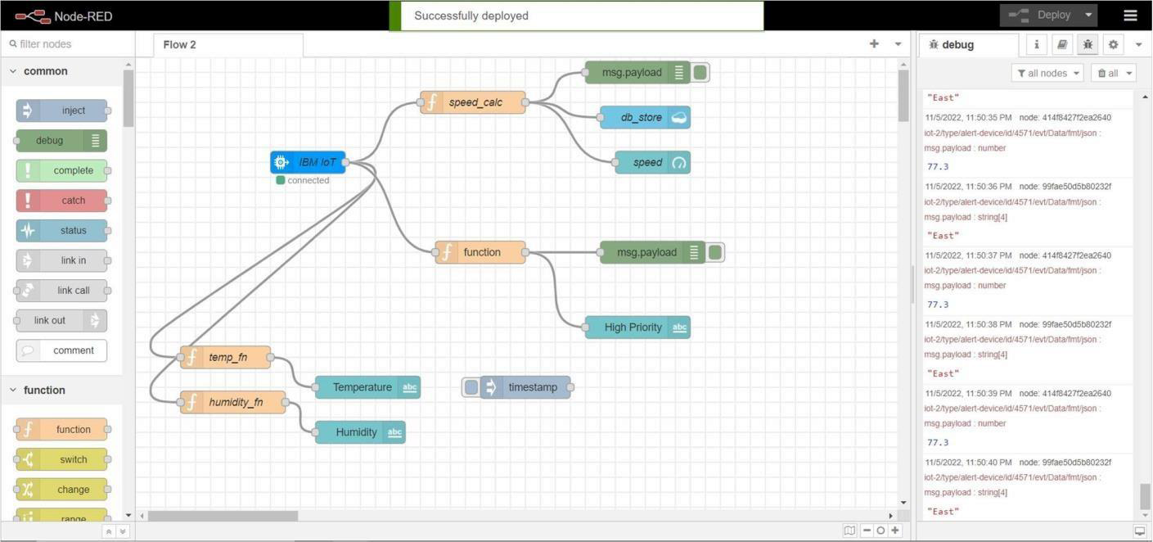
Node Red
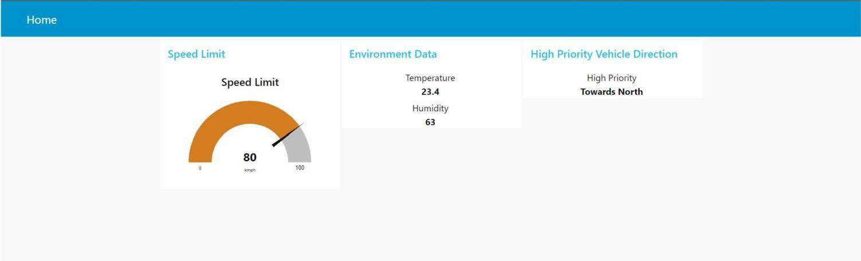
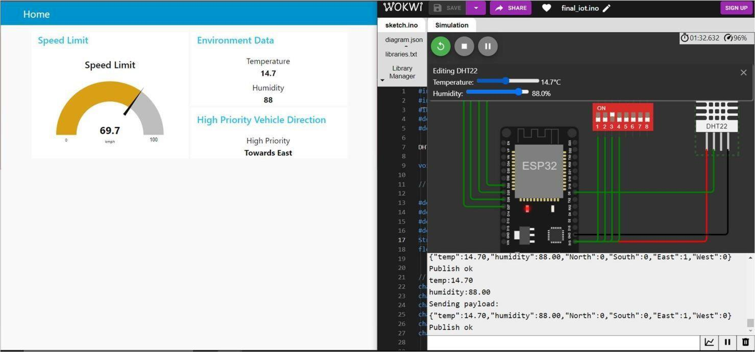
Node Red Web UI
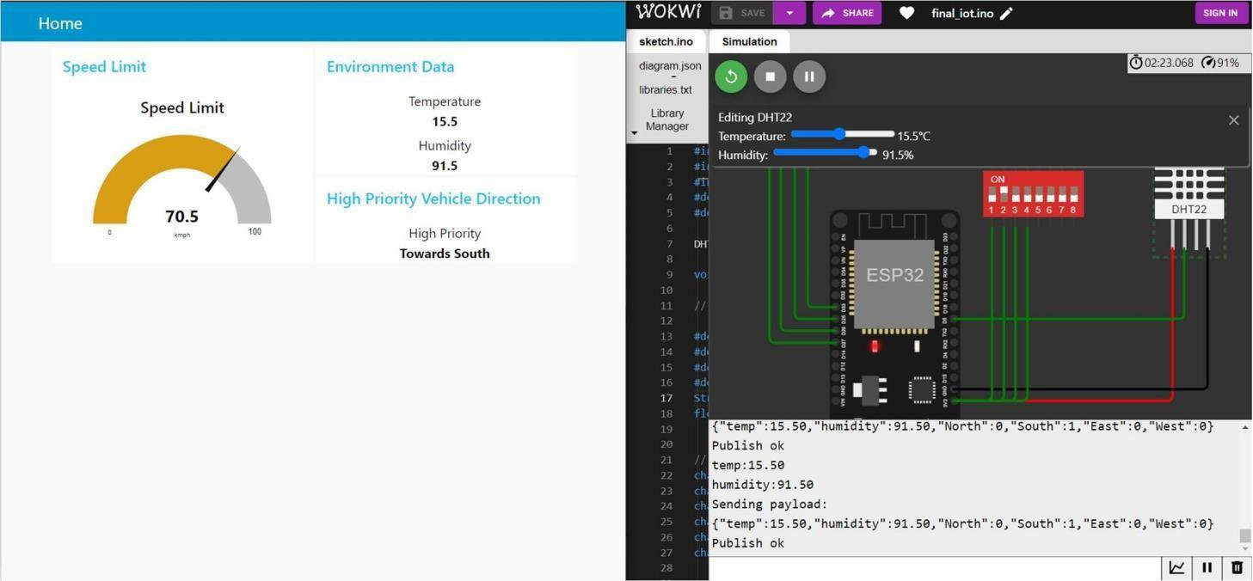
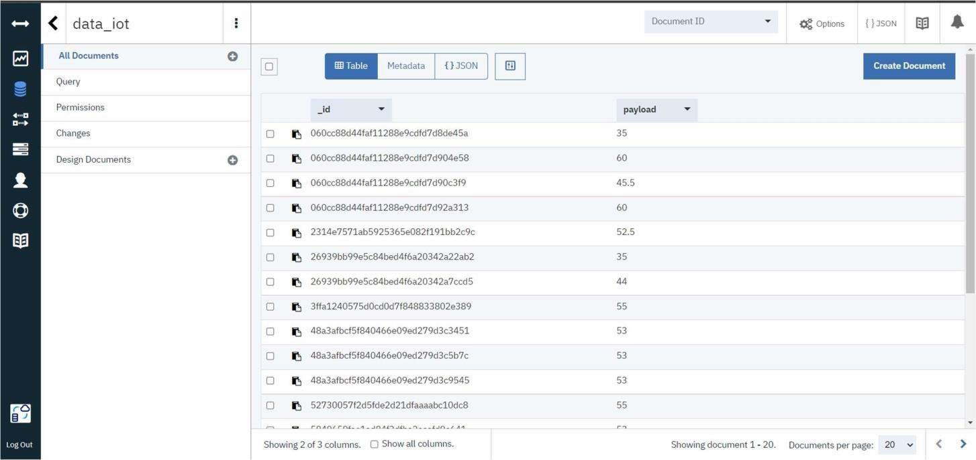
Cloudant Database

